

C0654 Auto Reserve Shop Order Material

Customisation Specifications

This document has been approved by

Steve Hardy | Sharon Standing
Business consultant | Solution owner or accountable role
Date | Date

TABLE OF CONTENTS
1.1 Description 6
1.2 Sub Function 7
1.2.1 Functional Requirement and Prerequisites 7
1.2.2 Functional Solution 7
1.3 Change log for revision XX 16

Document Revision History
Revision | Date | Author | Remarks
1 | 26/04/2021 | S. Hardy | 1st draft

Purpose and Guideance
This document specifies how the defined functions shall be developed or how the application shall be customized to solve the business requirements.

The Solution Description defines what will be delivered. The solution is matched against the requirements described in the Requirements section.
The Delimitations describe what is explicitly not covered by this customization. Together with the Solution description, these sections delimit the extent of the functional addition agreed for implementation.

Open Issues/Decisions Required
This specification cannot be completed until the following issues/decisions have been resolved:
Issue/Decision | Responsible
Shop Orders will be created from Shop Order Requisitions by Planners. Once all materials are available, the Shop Order will be ‘Released’.  The requirement is to automatically reserve materials based on pre-determined rules. | S. Standing

Business Requirements and References
Business requirements, references, sources and relations to other customizations are defined in Business requirement specification:
Document No | Rev | Document Name | Comments
?

Solution Description

Description
Shop Orders will be created by Manufacturing Planners from Shop Order Requisitions created by Master Scheduling (top level parts) or MRP (low level sub-assemblies). Once all checks have been performed, the Planner will ‘Release’ the shop order.
Some parts will be consumed from Manufacturing Kanbans while others will be issued from the main Stores/Warehouse and ‘kitted’.
Parts that are ‘Kitted’ will need to be reserved up to 4 days ahead so that the Warehouse have time to prepare the kits.
Parts that are consumed from Manufacturing Kanbans will need to be reserved up to 24 hours ahead.

Sub Function

Functional Requirement and Prerequisites
Functional Requirements
The functional requirement is to eliminate the need for Planners to manually reserve parts once the Shop Order has been ‘Released’.
‘Kitted’ parts, need to be reserved up to 4 days ahead of the Shop Order Start Date to give time for the Warehouse to prepare the kits.
‘Kanban’ parts need to be reserved 24 hours ahead of the Shop Order Start Date
Pre-requisites
For this to work consistently, the following pre-requisites must be in place
- The Shop Order header status is ‘Released’ for ‘Kitted’ parts
- The Shop Order header status is ‘Reserved’ for ‘Kanban’ parts
- All Material lines that have a Reserve/Issue Method of ‘Reserve’ are fully Reserved

Functional Solution
The functional solution is to automatically reserve parts. The solution is to run this process in two stages
Stage 1 – Kitted parts
Kitted parts are defined as any Component Part on the ‘Materials’ tab on the Shop Order that has a Reserve/Issue Method of ‘Reserve’. These need to be reserved up to 4 days before the Shop Order Start Date
Stage 2 – Kanban parts
Kanban parts are defined as any Component Part on the ‘Materials’ tab on the Shop Order that has a Reserve/Issue Method of ‘Reserve And Backflush’. These need to be reserved 1 day before the Shop Order Start Date

Manual Process

The process to reserve the material is identical for either type of part
The manual process to reserve material is shown below

Open Shop Order and select ‘Materials’ tab
Search for lines that have a ‘Reserve/Issue Method’ = ‘Reserve’ (Kitted parts) or ‘Reserve And Backflush’ (Kanban parts)

Highlight line, RMB and select ‘Reserve’

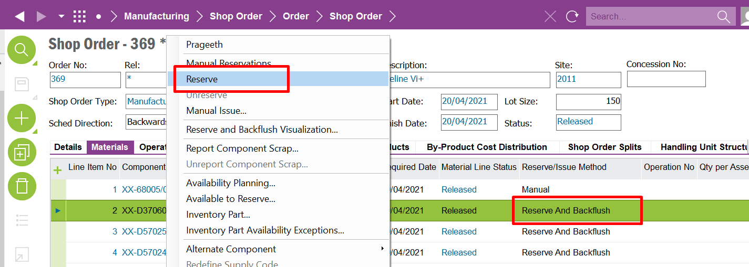
Select ‘Yes’

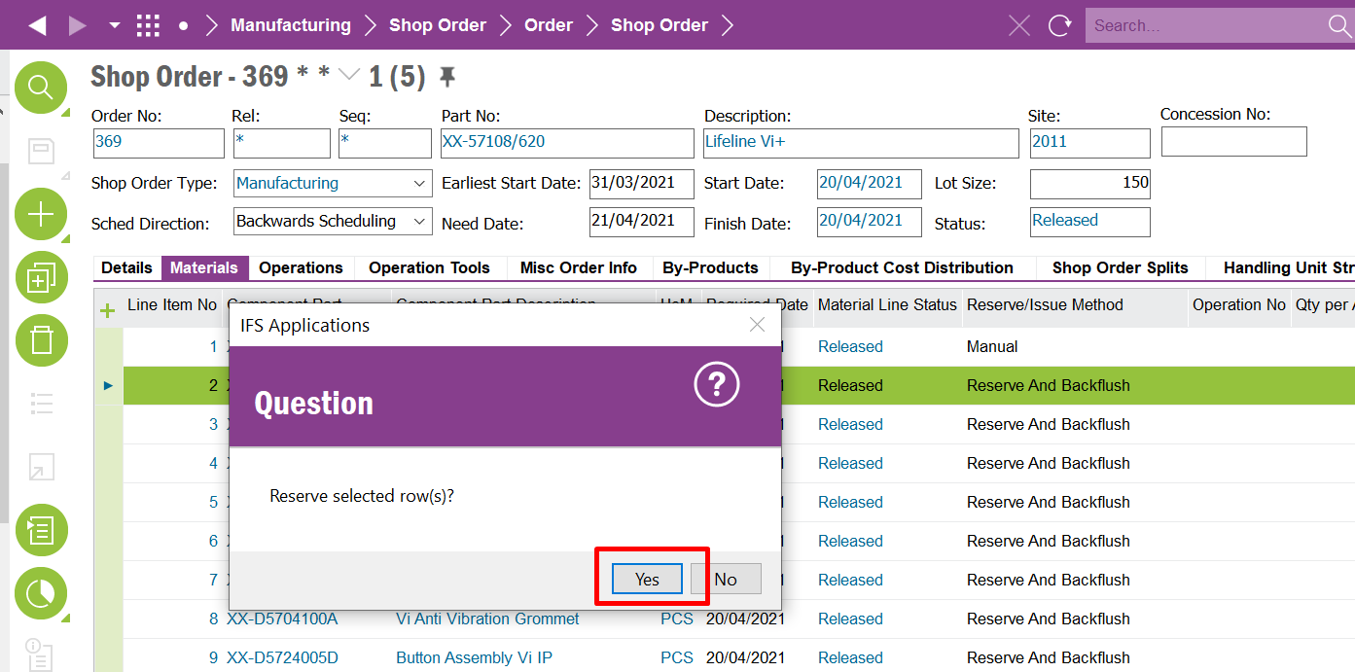

Check the quantity is reserved in full

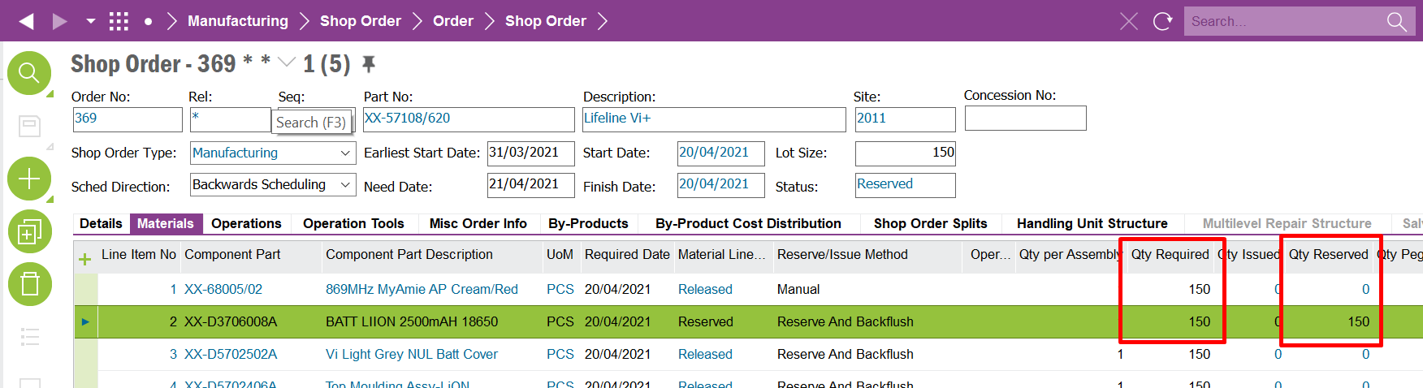

Event Logic

The events need to be run as a scheduled tasks to eliminate the need for user intervention.

Warehousing need time to prepare the kits, so the material reservation for parts stored in the Warehouse needs to be 4 days before the shop order is planned to start.
Parts stored in Manufacturing Kanban’s need to be reserved 1 day before the shop order is planned to start.
There are two events required for these requirements

Event 1 – Kitted parts

The event needs to replicate the manual process once fundamental status checks have been performed.

The event needs to perform the following checks before creating a pick list:
- Check the Shop Order is in a ‘Released’ or ‘Reserved’ state
- Discount Shop Order Material lines where the Consumption is ‘Not Consumed’
- Only look for Shop Order Material lines where the Reserve/Issue Method is ‘Reserve’
- Check that the Quantity Required – Quantity Reserved = 0

The event must only run for up to 4 days ahead of the shop order start date

The following SQL can be used to test these rules

select so.order_no,
so.release_no,
so.sequence_no,
so.part_no,
so.state,
soa.qty_required,
soa.qty_assigned,
soa.part_no
from ifsapp.shop_ord so,
ifsapp.SHOP_MATERIAL_ALLOC_UIV soa,
ifsapp.INV_PART_STOCK_RESERVATION_UIV sr
where so.order_no = soa.order_no
and so.order_no = sr.order_no (+)
and soa.order_no = sr.order_no (+)
and so.release_no = soa.release_no
and so.release_no = sr.line_no (+)
and soa.release_no = sr.line_no (+)
and so.sequence_no = soa.sequence_no
and soa.sequence_no = sr.release_no (+)
and so.sequence_no = sr.release_no (+)
and soa.part_no = sr.part_no (+)
and so.state in ('Released','Reserved')
and soa.issue_type = 'Reserve'
and soa.consumption_item = 'Consumed'
and soa.qty_required - soa.qty_assigned <> '0'
and so.REVISED_START_DATE < sysdate + 4

Note:- 4 days prior to Shop Order Start Days needs to be 4 working days i.e. excluding Saturday and Sunday

For all records found, ‘Reserve’ the material by selecting the Component Material Line, RMB and selecting ‘Reserve’

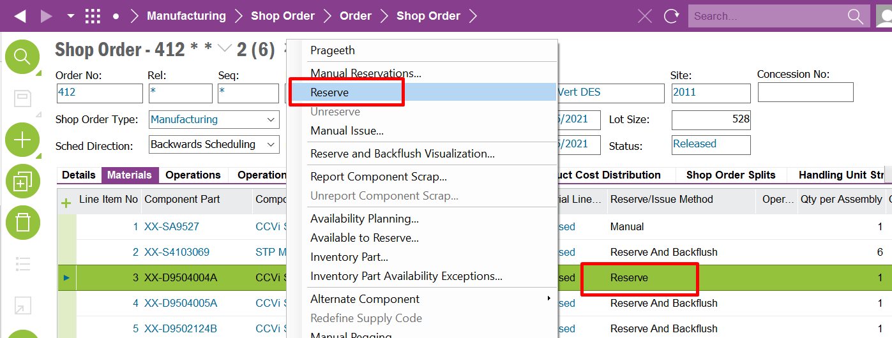

Event 2 – Kanban Parts

The event needs to perform the following checks before creating a pick list:
- Check the Shop Order is in a ‘Released’ or ‘ Reserved’ state
- Discount Shop Order Material lines where the Consumption is ‘Not Consumed’
- Only look for Shop Order Material lines where the Reserve/Issue Method is
‘Reserve and Backflush’
- Check that the Quantity Required – Quantity Reserved = 0

The event must only run for up to 1 day ahead of the shop order start date

select so.order_no,
so.release_no,
so.sequence_no,
so.part_no,
so.state,
soa.qty_required,
soa.qty_assigned,
soa.part_no
from ifsapp.shop_ord so,
ifsapp.SHOP_MATERIAL_ALLOC_UIV soa,
ifsapp.INV_PART_STOCK_RESERVATION_UIV sr
where so.order_no = soa.order_no
and so.order_no = sr.order_no (+)
and soa.order_no = sr.order_no (+)
and so.release_no = soa.release_no
and so.release_no = sr.line_no (+)
and soa.release_no = sr.line_no (+)
and so.sequence_no = soa.sequence_no
and soa.sequence_no = sr.release_no (+)
and so.sequence_no = sr.release_no (+)
and soa.part_no = sr.part_no (+)
and so.state in ('Released','Reserved')
and soa.issue_type = 'Reserve And Backflush'
and soa.consumption_item = 'Consumed'
and soa.qty_required - soa.qty_assigned <> '0'
and so.REVISED_START_DATE < sysdate + 1

Note:- 1 day prior to Shop Order Start Days needs to be 4 working days i.e. excluding Saturday and Sunday

For all records found, ‘Reserve’ the material by selecting the Component Material Line, RMB and selecting ‘Reserve’

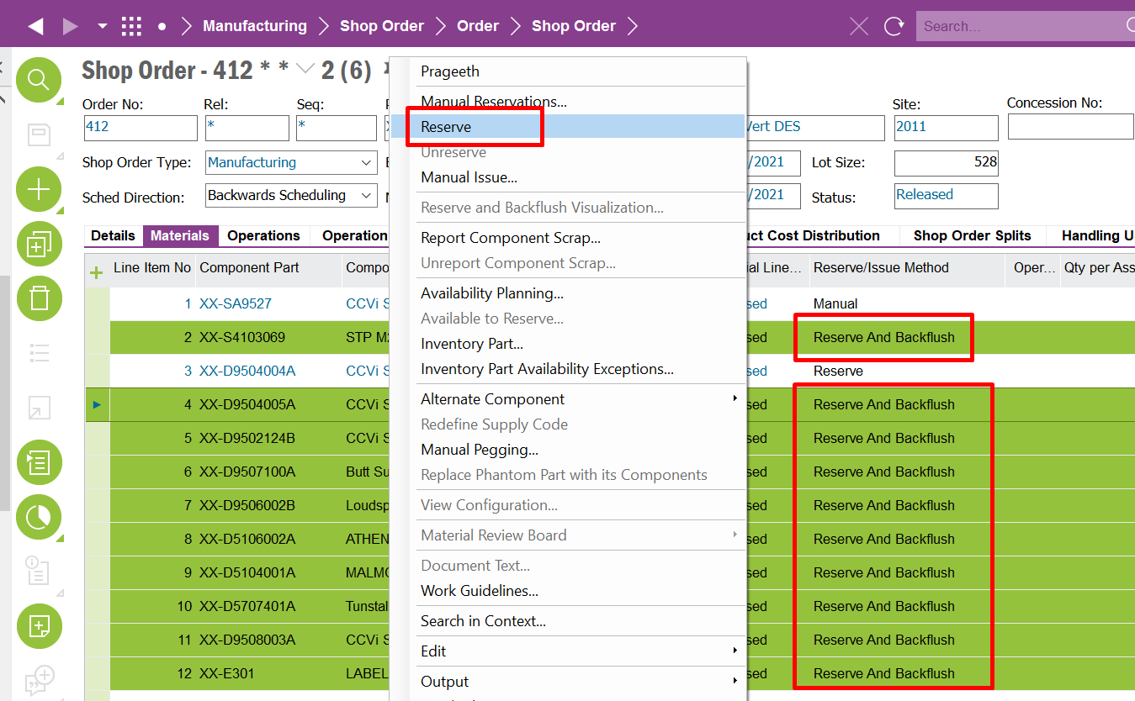

Delimitations

The configuration in this specification will be developed explicitly as written. Requests for changes in the configuration necessary to fulfil (or prepare for future fulfilment of) any requirements not explicitly described in the specification, will be considered outside the scope of this configuration.
Translations other than stated under chapter translations are not included in the scope for this specification.
Changes or extensions on Online Help (F1 Help), e-learning material or process models are excluded from this specification.

Translations
N/A
Prog Text | Translation | Window/form (optional) | Comment

Go Live Information/Upgrade Issues
N/A

Performance Considerations
N/A

Glossary/Acronyms
Commonly used IFS terms within this specification include:
Term | Explanation
LOV | List of Values. This refers to a source list of records from which to select in a form.
RMB | Right Mouse Button. Commonly used abbreviation

Change log, change requests

Change log for revision XX

Change # | Chapter | Description of the change
1
2
3
n | 3.2 | <New column Z added to existing window>

Detailed description of Change #1

Detailed description of Change #n

DELIVERY NOTES
Package – N/A
Attached INS FILE
Permissions Granted – IFS_ALL
Database Objects IFS Customer runtime configuration component CEACustomizationUtil C_EA_CUSTOMIZATIIN_API Reserve_Kitted_Kanban_Parts
Deployment Details
- Following methods needs to be available in the database Util package (C_EA_CUSTOMIZATION_UTIL_API).

- Check_Kitted_Reservation_Date
- Reserve_Kitted_Kanban_Parts
- Check_Kanban_Reservation_Date

- Deploy the attached INS file into the relevant database environment (Reserve_Kitted_Kanban_Parts)

- Refresh the Database Task Window and check for the
Database Task - Reserve_Kitted_Kanban_Parts
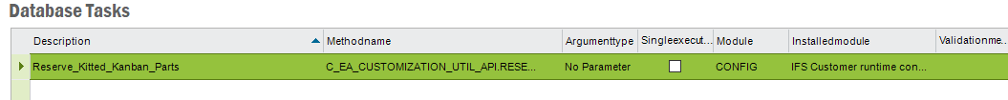

- Schedule needs to be created manually.

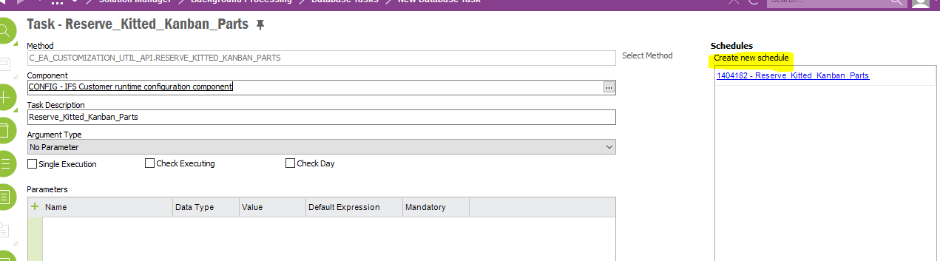

- Schedule Details

